Huawei FusionDirector for SCCM Plug-in
V1.1.3
 | User Guide
 | Issue | 01
 | Date | 2020-05-06

 | HUAWEI TECHNOLOGIES CO., LTD. |  | 

Copyright © Huawei Technologies Co., Ltd. 2020. All rights reserved.
No part of this document may be reproduced or transmitted in any form or by any means without prior written consent of Huawei Technologies Co., Ltd.

Trademarks and Permissions
and other Huawei trademarks are trademarks of Huawei Technologies Co., Ltd.
All other trademarks and trade names mentioned in this document are the property of their respective holders.

Notice
The purchased products, services and features are stipulated by the contract made between Huawei and the customer. All or part of the products, services and features described in this document may not be within the purchase scope or the usage scope. Unless otherwise specified in the contract, all statements, information, and recommendations in this document are provided "AS IS" without warranties, guarantees or representations of any kind, either express or implied.
The information in this document is subject to change without notice. Every effort has been made in the preparation of this document to ensure accuracy of the contents, but all statements, information, and recommendations in this document do not constitute a warranty of any kind, express or implied.

Huawei Technologies Co., Ltd.
Address: | Huawei Industrial Base  Bantian, Longgang  Shenzhen 518129  People's Republic of China
Website: | https://www.huawei.com
Email: | support@huawei.com

Preface
Purpose
This document describes how to install and uninstall the Huawei SCCM plug-in, add FusionDirector, and use the Huawei SCCM plug-in to manage Huawei servers.
Intended Audience
This document is intended for upgrade personnel. Upgrade personnel must:
- Be familiar with the product networking and related NEs' versions.
- Have device maintenance experience and be familiar with device operation and maintenance.
Symbol Conventions
The symbols that may be found in this document are defined as follows.
Symbol | Description
 | Indicates an imminently hazardous situation which, if not avoided, will result in death or serious injury.
 | Indicates a potentially hazardous situation which, if not avoided, could result in death or serious injury.
 | Indicates a potentially hazardous situation which, if not avoided, may result in minor or moderate injury.
 | Indicates a potentially hazardous situation which, if not avoided, could result in equipment damage, data loss, performance deterioration, or unanticipated results.  NOTICE is used to address practices not related to personal injury.
Calls attention to important information, best practices and tips.
NOTE is used to address information not related to personal injury, equipment damage, and environment deterioration.

Change History
Issue | Date | Description
01 | 2020-05-06 | This issue is the first official release.

Contents
Preface ii
1 Overview 1
2 Installing and Uninstalling the Huawei SCCM Plug-in 2
2.1 Installing the Huawei SCCM Plug-in 2
2.2 Uninstalling the Huawei SCCM Plug-in 5
3 Operation and Maintenance 10
3.1 Configuring FusionDirector 10
3.1.1 Adding FusionDirector 10
3.1.2 Editing FusionDirector 13
3.1.3 Deleting FusionDirector 16
3.2 Viewing the Server List 17
3.3 Deploying an OS 19
3.3.1 Managing OS Images 19
3.3.2 Adding an OS Template 22
3.3.3 Deploying an OS Using a Template 25
3.4 Configuring a Server Using a Profile 27
3.4.1 Creating a Server Profile 27
3.4.2 Querying Server Profiles 30
3.4.3 Modifying a Server Profile 32
3.4.4 Configuring Servers Using a Server Profile 34
3.4.5 Deleting a Server Profile 37
3.5 Upgrading Firmware and Drivers 39
3.5.1 Version Repository Management 40
3.5.1.1 Uploading an Update Package 40
3.5.1.2 Customizing a Baseline 43
3.5.2 Update Schedule Management 47
3.5.2.1 Creating an Update Schedule 47
3.5.2.2 Viewing the Update Schedule 50
3.5.3 Checking Device Version and Status 51
3.6 Managing Tasks 53
3.7 Viewing the Huawei SCCM Plug-in Version 54
4 FAQs 55
4.1 Connection Test Failed When You Add FusionDirector Server 55
4.2 DLL File Is Missing When the SCCM Plug-in Is Used 56
A Obtaining Help 58
A.1 Preparing to Contact Huawei Technical Support 58
A.2 Obtaining Help from Huawei Support Website 58

Overview
Function Description
The Huawei SCCM plug-in is a plug-in integrated in the System Center Configuration Manager (SCCM for short) software and used for Huawei server management. By adding FusionDirector, it can implement the OS deployment, server configuration, and upgrade functions on Huawei servers.
You can implement the following functions by using the Huawei SCCM plug-in:
- Deploy OSs on servers in batches. Table 1-2 lists the OSs that can be deployed.
- Configure the NIC, BMC, BIOS, and RAID.
- Update server firmware and drivers.


The actual functions depend on the functions provided by FusionDirector.
Supported Servers
Type | Server Model
Rack server | 1288H V5
Rack server | 2288H V5
Heterogeneous server | G560
Heterogeneous server | G530 V5
Heterogeneous server | G560 V5
Blade server | E9000 (MM920)

Installing and Uninstalling the Huawei SCCM Plug-in
2.1 Installing the Huawei SCCM Plug-in
2.2 Uninstalling the Huawei SCCM Plug-in

Installing the Huawei SCCM Plug-in
            - Log in to GitHub, and obtain the plug-in installation package.
            - Upload the Huawei SCCM plug-in installation package to the SCCM server OS.
            - Log in to the SCCM server.
            - Decompress the Huawei SCCM plug-in installation package on the SCCM server.
The Huawei SCCM plug-in installation program (such as Huawei_SCCM_Plugin_For_Fusion_Director_x.x.x.exe) is obtained.
            - Double-click the Huawei SCCM plug-in installation program.
The language selection window is displayed, as shown in Figure 1-1.
              - Selecting a language
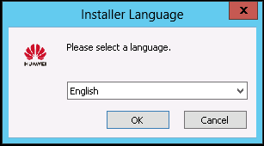

            - Select an installation language, and click OK.
The installation wizard is displayed, as shown in Figure 1-1.
              - Installation wizard
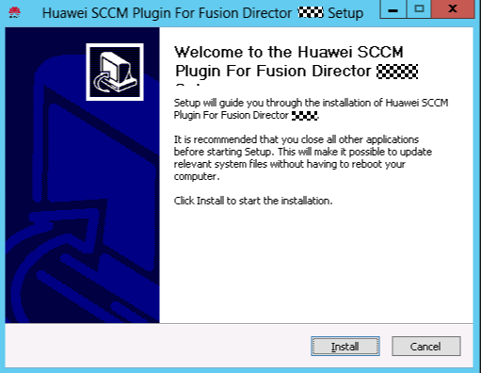

            - Click Install.
The Huawei SCCM plug-in installation starts, as shown in Figure 1-1.
              - Installation progress
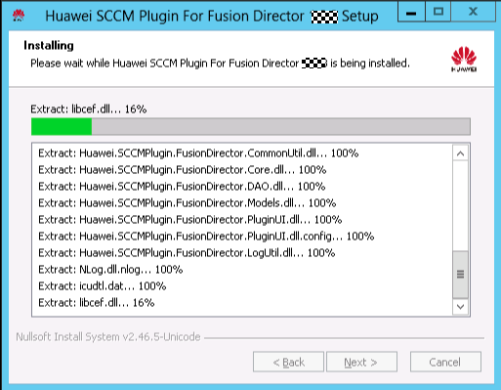

When the installation is complete, the window shown in Figure 1-2 is displayed.
              - Installation completed
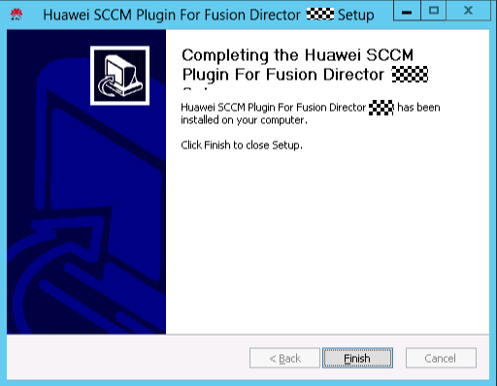

            - Click Finish.
The installation is complete.
----End

Uninstalling the Huawei SCCM Plug-in
You can use either of the following methods to uninstall the plug-in:
- Uninstalling the Huawei SCCM plug-in from the Control Panel
- Uninstalling the Huawei SCCM plug-in from the Huawei SCCM plug-in installation directory.
Uninstalling the Huawei SCCM plug-in from the Control Panel
            - Log in to the SCCM server.
            - Uninstall the Huawei SCCM plug-in.
- Choose Start > Control Panel > Programs and Features.
The Programs and Features window is displayed, as shown in Figure 1-1.
              - Programs and Features
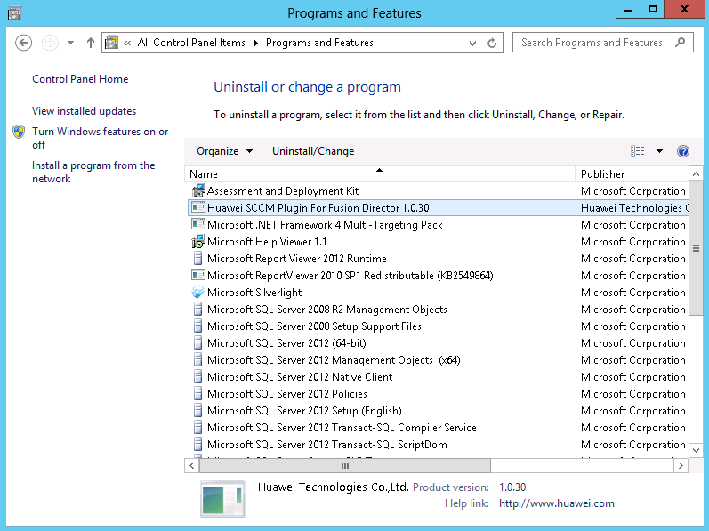

- Find the Huawei SCCM plug-in (such as Huawei_SCCM_Plugin_For_Fusion_Director_x.x.x.exe) and double-click it.
The confirmation dialog box is displayed, as shown in Figure 1-2.
              - Dialog box
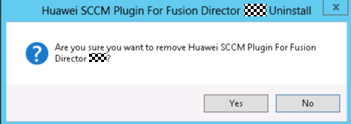

- Confirm the uninstallation, and click Yes.
The Huawei SCCM plug-in uninstallation starts, and a dialog box prompting you to confirm data deletion is displayed, as shown in Figure 1-3.
              - Dialog box
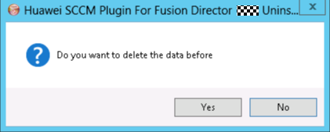

- Confirm the data deletion, and click Yes.
A dialog box indicating successful uninstallation is displayed, as shown in Figure 1-4.
              - Dialog box
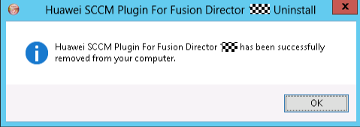

- Click OK.
The plug-in is uninstalled successfully.
----End
Uninstalling the Huawei SCCM plug-in from the Huawei SCCM plug-in installation directory.
            - Log in to the SCCM server.
            - Uninstall the Huawei SCCM plug-in.
- Go to the Huawei SCCM plug-in installation directory, as shown in Figure 1-1.
              - Going to the Huawei SCCM plug-in installation directory
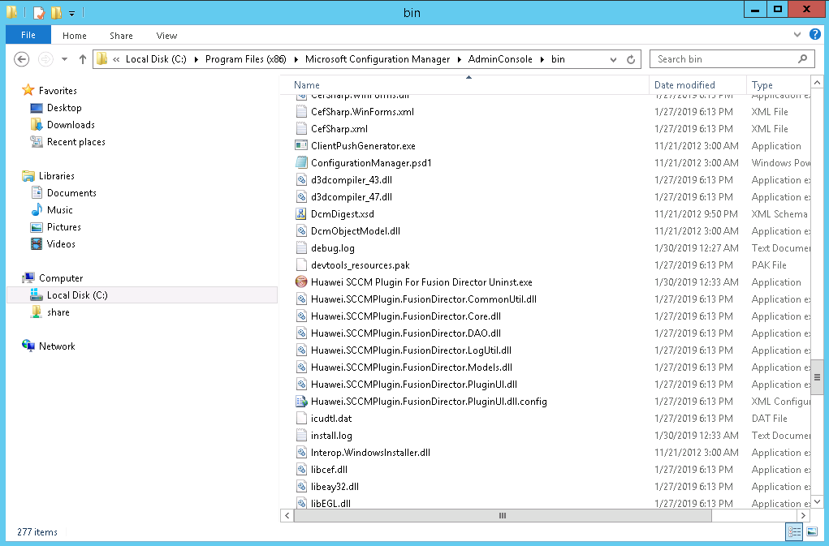

- Find the Huawei SCCM Plugin For Fusion Director Uninst.exe and double-click it.
The confirmation dialog box is displayed, as shown in Figure 1-2.
              - Dialog box

- Confirm the uninstallation, and click Yes.
The Huawei SCCM plug-in uninstallation starts, and a dialog box prompting you to confirm data deletion is displayed, as shown in Figure 1-3.
              - Dialog box

- Confirm the data deletion, and click Yes.
A dialog box indicating successful uninstallation is displayed, as shown in Figure 1-4.
              - Dialog box

- Click OK.
The plug-in is uninstalled successfully.
----End

Operation and Maintenance
3.1 Configuring FusionDirector
3.2 Viewing the Server List
3.3 Deploying an OS
3.4 Configuring a Server Using a Profile
3.5 Upgrading Firmware and Drivers
3.6 Managing Tasks
3.7 Viewing the Huawei SCCM Plug-in Version

Configuring FusionDirector

Adding FusionDirector
            - Log in to the SCCM server.
            - Choose Start > Configuration Manager Console to log in to the SCCM.

If Configuration Manager Console cannot be found on the Start panel, return to the desktop, right-click Start, choose Search from the shortcut menu, and enter Configuration Manager Console in the search box to find Configuration Manager Console.
The SCCM main window is displayed, as shown in Figure 1-1.
              - SCCM main window
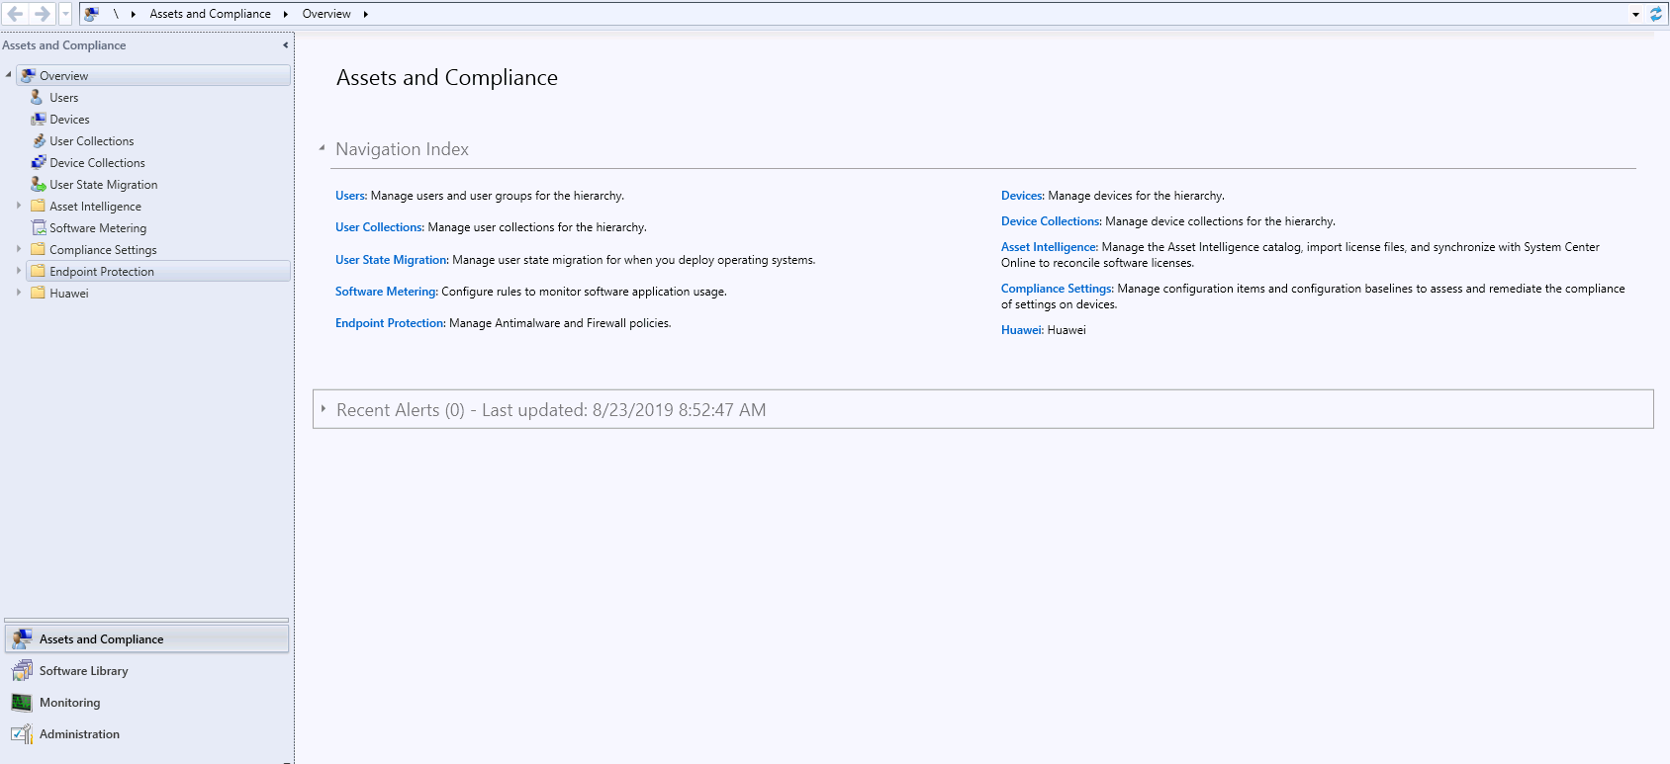

            - Choose Huawei > FusionDirector Setting.
The FusionDirector Setting window is displayed, as shown in Figure 1-1.
              - FusionDirector Setting
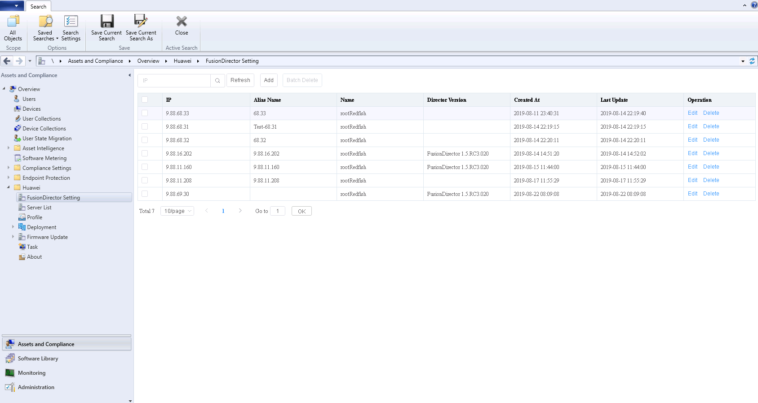

            - Click Add.
The Add FusionDirector window is displayed, as shown in Figure 1-1.
              - Add FusionDirector
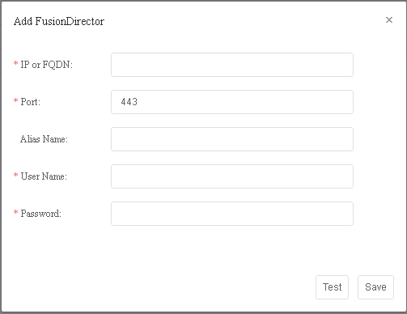

Table 1-1 describes the parameters.
                - Parameter description
Parameter | Description | Mandatory
IP or FQDN | FusionDirector IP address or domain name | Yes
Port | FusionDirector northbound port number. The default value is 443. | Yes
Alias Name | Customized FusionDirector name. The value contains 1 to 100 characters and supports letters, digits, underscores, em dashes (—), and dots (.). | No
User Name | FusionDirector northbound port user name. The default value is rootRedfish. | Yes
Password | FusionDirector northbound port password. The default value is Machine@123. To change the password, follow the instructions in 4.1 Connection Test Failed When You Add FusionDirector Server. | Yes

            - Enter FusionDirector information according to Table 1-1, and click Test to check whether the configuration information is correct.
If "Link test successfully" is displayed in the window, the entered FusionDirector information is correct. If any error occurs, enter FusionDirector information again.
            - Click Save.
A dialog box indicating successful adding is displayed, as shown in Figure 1-1.
              - Dialog box


            - Click OK.
The FusionDirector is added successfully.
----End

Editing FusionDirector
            - Log in to the SCCM server.
            - Choose Start > Configuration Manager Console to log in to the SCCM.
If Configuration Manager Console cannot be found on the Start panel, return to the desktop, right-click Start, choose Search from the shortcut menu, and enter Configuration Manager Console in the search box to find Configuration Manager Console.
The SCCM main window is displayed, as shown in Figure 1-1.
              - SCCM main window

            - Choose Huawei > FusionDirector Setting.
The FusionDirector Setting window is displayed, as shown in Figure 1-1.
              - FusionDirector Setting

            - Click Edit in the row where the FusionDirector to be edited is located.
The Edit FusionDirector window is displayed, as shown in Figure 1-1.
              - Edit FusionDirector
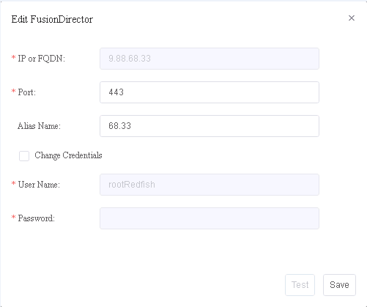

            - Edit FusionDirector information according to Table 1-1, and click Save.

- The FusionDirector IP address cannot be modified.
- Change Credentials must be selected if the FusionDirector user name and password are to be changed.
A dialog box indicating successful editing is displayed, as shown in Figure 1-1.
              - Dialog box
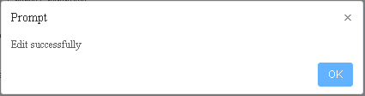

            - Click OK.
The FusionDirector is edited successfully.
----End

Deleting FusionDirector
            - Log in to the SCCM server.
            - Choose Start > Configuration Manager Console to log in to the SCCM.
If Configuration Manager Console cannot be found on the Start panel, return to the desktop, right-click Start, choose Search from the shortcut menu, and enter Configuration Manager Console in the search box to find Configuration Manager Console.
The SCCM main window is displayed, as shown in Figure 1-1.
              - SCCM main window

            - Choose Huawei > FusionDirector Setting.
The FusionDirector Setting window is displayed, as shown in Figure 1-1.
              - FusionDirector Setting

            - Click Delete in the row where the FusionDirector is located.
The confirmation dialog box is displayed, as shown in Figure 1-1.
              - Dialog box


You can select multiple FusionDirector systems and click Batch Delete to delete them in batches.
            - Click OK.
The FusionDirector is deleted successfully.
----End

Viewing the Server List
            - Log in to the SCCM server.
            - Choose Start > Configuration Manager Console to log in to the SCCM.
If Configuration Manager Console cannot be found on the Start panel, return to the desktop, right-click Start, choose Search from the shortcut menu, and enter Configuration Manager Console in the search box to find Configuration Manager Console.
The SCCM main window is displayed, as shown in Figure 1-1.
              - SCCM main window

            - Choose Huawei > Server List.
The Server List window is displayed, as shown in Figure 1-1.
              - Server List
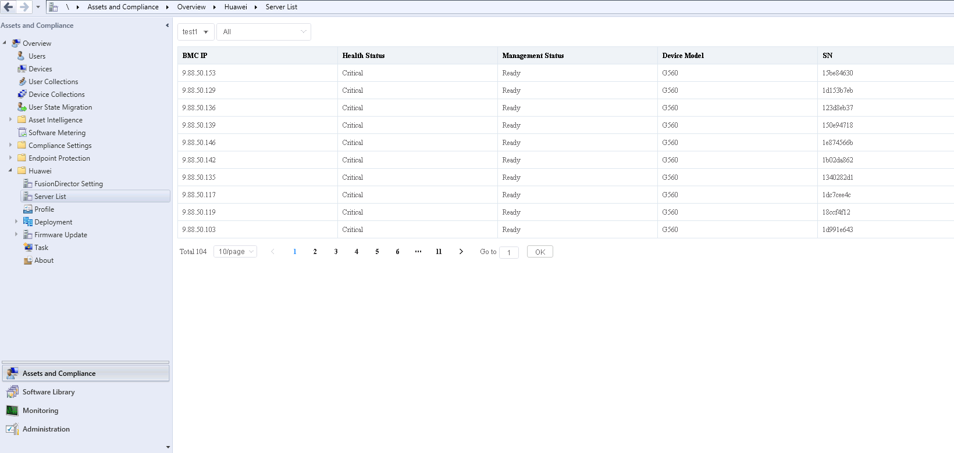

You can view the servers managed by each FusionDirector system in this window.
- test1 in Figure 1-1 indicates the FusionDirector alias. You can select another FusionDirector system from the drop-down list box.
- All in Figure 1-1 indicates that all servers are viewed. You can select a server from the drop-down list.
----End

Deploying an OS

Managing OS Images
Scenario
To deploy an OS on a server, you need to add an OS image, add an OS template, and add an OS deployment task.
Prerequisites
A standard OS image in the ISO format has been downloaded to the local PC.
Procedure
            - Log in to the SCCM server.
            - Choose Start > Configuration Manager Console to log in to the SCCM.
If Configuration Manager Console cannot be found on the Start panel, return to the desktop, right-click Start, choose Search from the shortcut menu, and enter Configuration Manager Console in the search box to find Configuration Manager Console.
The SCCM main window is displayed, as shown in Figure 1-1.
              - SCCM main window

            - Choose Huawei > Deployment > OS Image.
The OS Image window is displayed, as shown in Figure 1-1.
              - OS Image
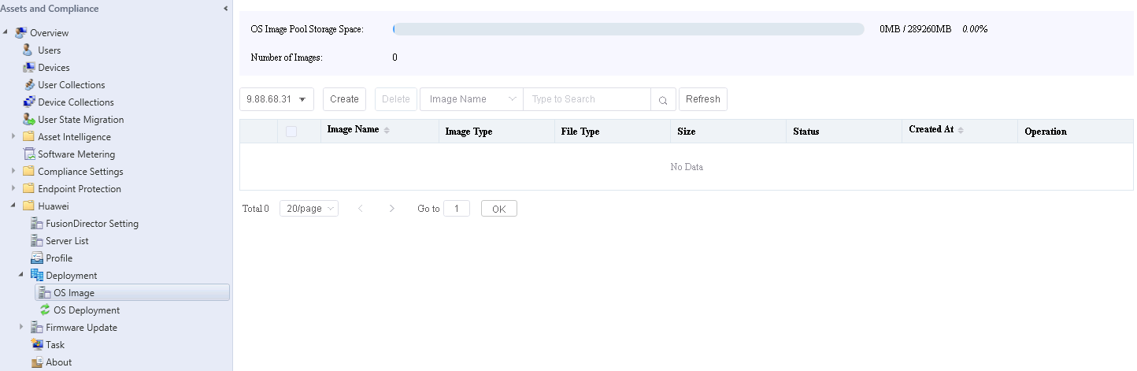

            - Click Create.
The page for creating an OS image is displayed, as shown in Figure 1-1.
              - Creating an OS image
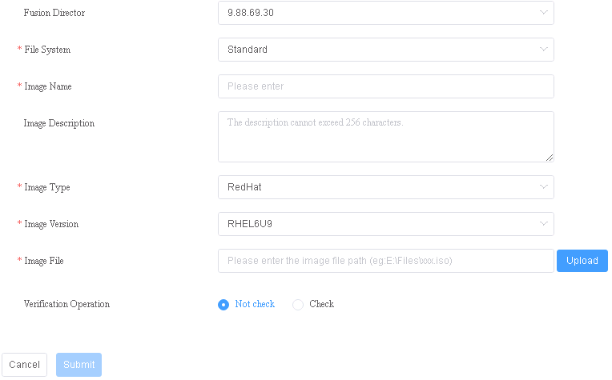

Table 1-1 describes the parameters.
                - Parameter description
Parameter | Description | Value | Mandatory
Fusion Director | FusionDirector ID. | ID of a FusionDirector that has been added. | Yes
File System | Image file type. | The value can be only Standard currently. | Yes
Image Name | Image name. | The value contains 1 to 32 characters, including only letters, digits, hyphens (-), underscores (_), and dots (.). | Yes
Image Description | OS image description. | The value contains 0 to 256 characters. | No
Image Type | OS image type. | The options are as follows:  - RedHat  - Ubuntu  - VMware  - SUSE  - CentOS  - Windows  - EulerOS | Yes
Image Version | Software source version. | A software source type includes one or multiple versions. For details, see Table 1-2. | Yes
Image File | Image file path. | The local file path must contain .iso. | Yes
Verification Operation | Whether to perform verification. | The value is Not check or Check. Two encryption modes are available for Check, SHA256 and MD5. | Yes

                - Supported software source versions
Software Source Type | Version
Windows | Windows Server 2012 R2 x64
Windows | Windows Server 2016 x64
SUSE | SUSE Linux Enterprise 11 SP4 x64
SUSE | SUSE Linux Enterprise 12 SP2 x64
SUSE | SUSE Linux Enterprise 12 SP3 x64
Red Hat | Red Hat Linux Enterprise 6.9 x64
Red Hat | Red Hat Linux Enterprise 7.3 x64
Red Hat | Red Hat Linux Enterprise 7.4 x64
Red Hat | Red Hat Linux Enterprise 7.5 x64
Red Hat | Red Hat Linux Enterprise 7.6 x64
CentOS | CentOS Linux Enterprise 6.9 x64
CentOS | CentOS Linux Enterprise 7.3 x64
CentOS | CentOS Linux Enterprise 7.4 x64
CentOS | CentOS Linux Enterprise 7.5 x64
CentOS | CentOS Linux Enterprise 7.6 x64
Ubuntu | Ubuntu Linux Enterprise 16.04 x64
Ubuntu | Ubuntu Linux Enterprise 16.04.1 x64
Ubuntu | Ubuntu Linux Enterprise 16.04.2 x64
VMWare ESXi | VMWare ESXi 6.0 x64
VMWare ESXi | VMWare ESXi 6.5 x64
VMWare ESXi | VMWare ESXi 6.7 x64
EulerOS | EulerOSV2SP3

            - Click Submit. The OS image is added successfully.
Click Refresh to refresh the window. Then you can view the added OS image in the OS image list, as shown in Figure 1-1.
              - OS image list
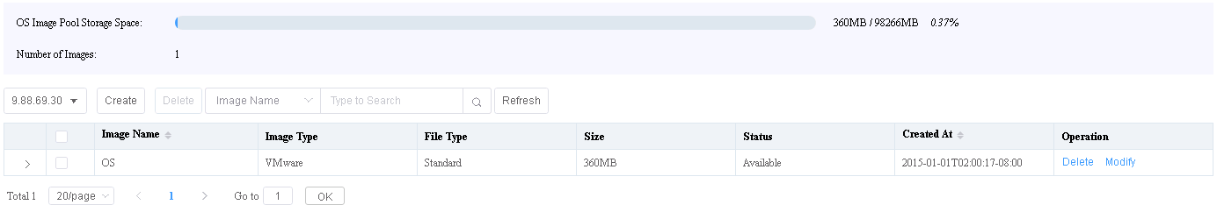

- If the OS image fails to be created, you can view the task failure information on the Task page.
- You can click Delete or Modify in the row where an OS image is located to delete or modify the OS image.
----End

Adding an OS Template
            - Log in to the SCCM server.
            - Choose Start > Configuration Manager Console to log in to the SCCM.
If Configuration Manager Console cannot be found on the Start panel, return to the desktop, right-click Start, choose Search from the shortcut menu, and enter Configuration Manager Console in the search box to find Configuration Manager Console.
The SCCM main window is displayed, as shown in Figure 1-1.
              - SCCM main window

            - Choose Huawei > Deployment > OS Deployment.
The OS Deployment window is displayed, as shown in Figure 1-1.
              - OS Deployment
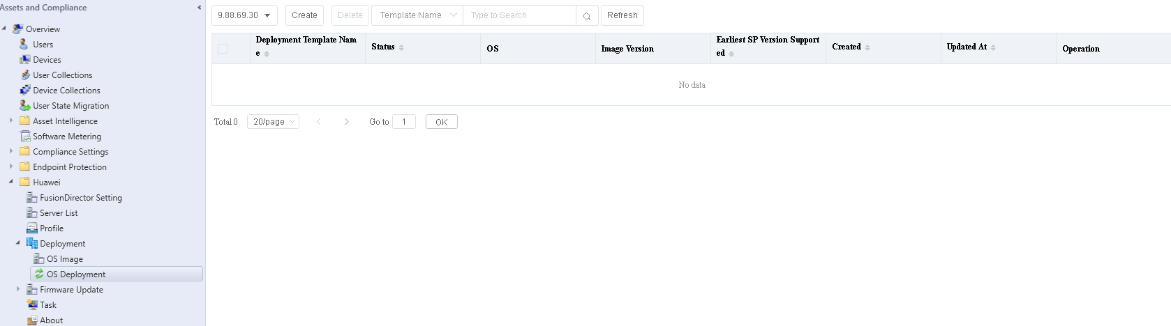

            - Click Create.
The page for creating an OS deployment template is displayed, as shown in Figure 1-1.
Table 1-1 describes the parameters.
The Installation Information area is displayed only after you select an OS image in the Basic Information area.
              - Creating an OS deployment template
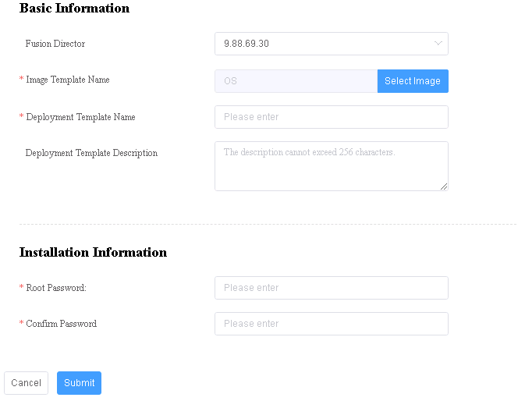

                - Parameter description
Parameter | Description | Value | Mandatory
Fusion Director | FusionDirector ID. | ID of a FusionDirector that has been added. | Yes
Image Template Name | Image name. | The name of an OS image that has been created in the system. You can click Select Image to select an OS image. | Yes
Deployment Template Name | Name of the deployment template. | The value contains 1 to 32 characters, including letters, digits, hyphens (-), underscores (_), and dots (.). | Yes
Deployment Template Description | Template description. | The value contains 0 to 256 characters. | No
Root Password | OS administrator password. | The value contains 6 to 32 characters and must consist of at least two types of the following characters: uppercase letters, lowercase letters, digits, and special characters (`~!@$%......&*()-_=+|[{}];:' ",<.>/? #). | Yes
Confirm Password | Password for confirmation. | The value needs to be the same as the configured OS administrator password. | Yes

            - Click Submit.
The OS template is added successfully, and you can view the added OS template in the template list, as shown in Figure 1-1.
              - Template list
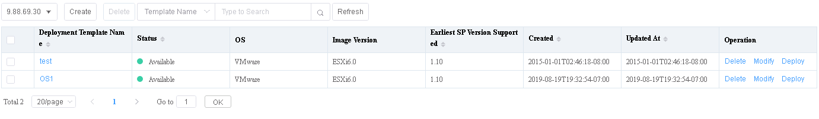

- If there are many OS images, you can filter images by image name.
- To delete or modify a template, click Delete or Modify in the row where the template is located.
----End

Deploying an OS Using a Template
OS templates can be used to deploy OSs on managed servers in batches, improving deployment efficiency.
Procedure
            - Log in to the SCCM server.
            - Choose Start > Configuration Manager Console to log in to the SCCM.
If Configuration Manager Console cannot be found on the Start panel, return to the desktop, right-click Start, choose Search from the shortcut menu, and enter Configuration Manager Console in the search box to find Configuration Manager Console.
The SCCM main window is displayed, as shown in Figure 1-1.
              - SCCM main window

            - Choose Huawei > Deployment > OS Deployment.
The OS Deployment window is displayed, as shown in Figure 1-1.
              - OS Deployment

            - Select a deployment template to deploy the OS.
- Click Deploy.
The template deployment page is displayed, as shown in Figure 1-1.
              - OS Deployment
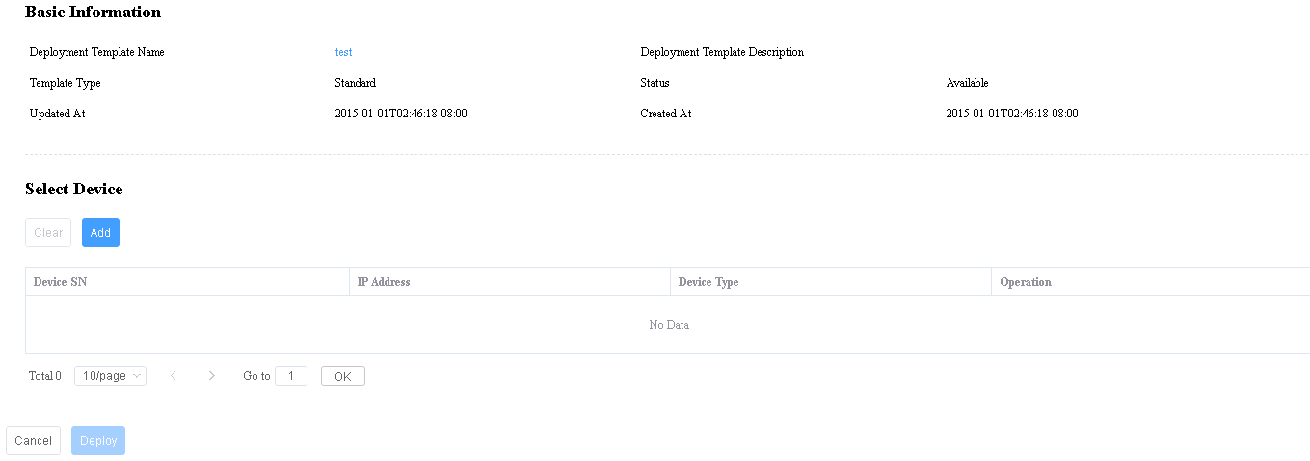

- In the Select Device area, click Add.
The Add New Device dialog box is displayed.
- Select the server where the OS is to be deployed and click OK, as shown in Figure 1-2.
              - Add New Device dialog box
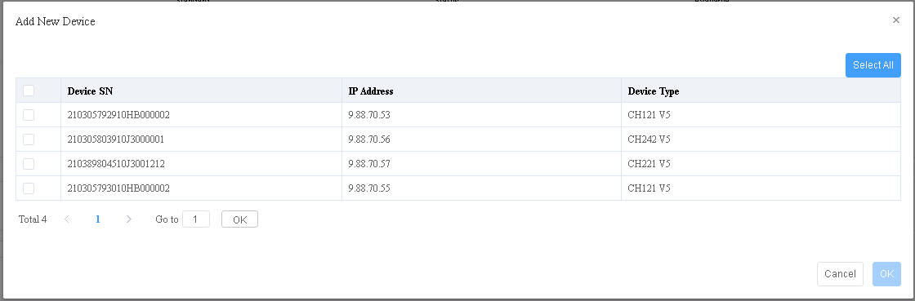

- In the OS Deployment window, click Deploy to start the deployment task.
You can view the deployment progress on the Task page. If the task status is Successful, the deployment is successful.
----End

Configuring a Server Using a Profile
Servers can be configured in batches using a profile, greatly improving server configuration efficiency. The current profiles can be used to configure the server BIOS, RAID, and BMC.

Creating a Server Profile
            - Log in to the SCCM server.
            - Choose Start > Configuration Manager Console to log in to the SCCM.
If Configuration Manager Console cannot be found on the Start panel, return to the desktop, right-click Start, choose Search from the shortcut menu, and enter Configuration Manager Console in the search box to find Configuration Manager Console.
The SCCM main window is displayed, as shown in Figure 1-1.
              - SCCM main window

            - Choose Huawei > Profile.
The server profile management page is displayed, as shown in Figure 1-1.
              - Server profile management page
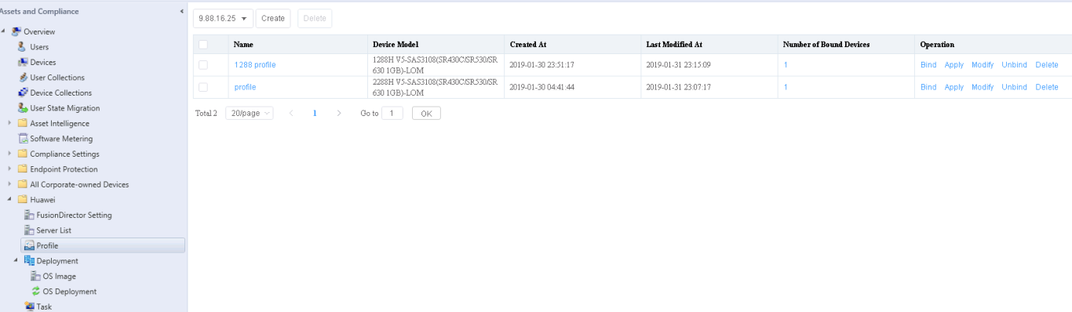

            - Click Create.
The page for creating a server profile is displayed, as shown in Figure 1-1. Table 1-1 describes the parameters.
BIOS Configuration, RAID Configuration, and BMC Configuration are displayed only after Device Model is selected.
              - Creating a server profile
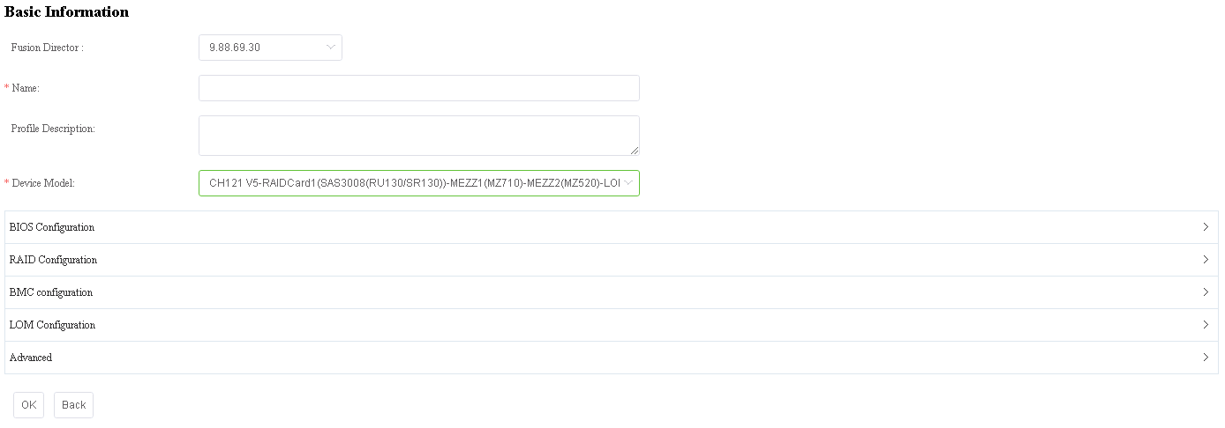

                - Server profile parameters
Parameter | Description | Value | Mandatory
Fusion Director | FusionDirector ID. | ID of a FusionDirector that has been added. | Yes
Name | Profile name. | The value contains 1 to 45 characters, including letters, digits, underscores (_), hyphens (-), and spaces. | Yes
Profile Description | Profile description. | The value contains 0 to 1024 characters. | No
Device Model | Device type. | The type of the device that has been managed by the system. It is automatically determined by the device managed by the system. | Yes
BIOS Configuration | BIOS configuration. | BIOS configurations include Boot, Boot Sequence, Advanced Power Management Configuration, Intel VT for Directed I/O(VT-D), Processor Configuration, Memory Configuration, Console Redirection, iBMC Configuration, PXE Configuration, UPI Configuration, Power, Advanced Socket Configuration and IIO Configuration. For details, see the FusionDirector User Guide.  NOTE  Advanced Socket Configuration is available when E9000 compute nodes are used. | Yes
RAID Configuration | RAID configuration. | You can delete existing logical disks and create logical disks. For details, see the FusionDirector User Guide. | Yes
BMC Configuration | BMC configuration. | You can perform the BMC NTP, DNS, and LDAP configurations. For details, see the FusionDirector User Guide. | Yes
LOM Configuration | LOM configuration. | LOM configuration dependency is as follows:  NOTE  LOM Configuration is available when E9000 compute nodes are used.  - Set Boot Type of BIOS Configuration to UEFI Boot.  - Set LOM Enabled of Advanced Socket Configuration of BIOS Configuration to Enabled or Auto.  - Set Clear NIC Unique Key of Advanced to FALSE or Unchanged. | Yes
Advanced | Configuration of advanced parameters. | You can set Auto GUID Setting and Clear NIC Unique Key. For details, see the FusionDirector User Guide.  NOTE  Advanced is available when E9000 compute nodes are used. | Yes

            - Click OK.
The file is created.
----End

Querying Server Profiles
            - Log in to the SCCM server.
            - Choose Start > Configuration Manager Console to log in to the SCCM.
If Configuration Manager Console cannot be found on the Start panel, return to the desktop, right-click Start, choose Search from the shortcut menu, and enter Configuration Manager Console in the search box to find Configuration Manager Console.
The SCCM main window is displayed, as shown in Figure 1-1.
              - SCCM main window

            - Choose Huawei > Profile.
The server profile page is displayed, as shown in Figure 1-1. You can view the list of server profiles that have been created in the system.
              - Querying server profiles
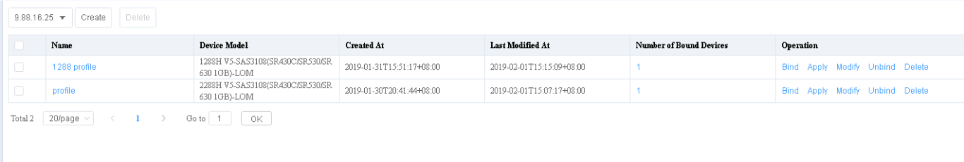

            - Click the name of a specified server profile.
The server profile details are displayed, as shown in Figure 1-1.
              - Server profile details
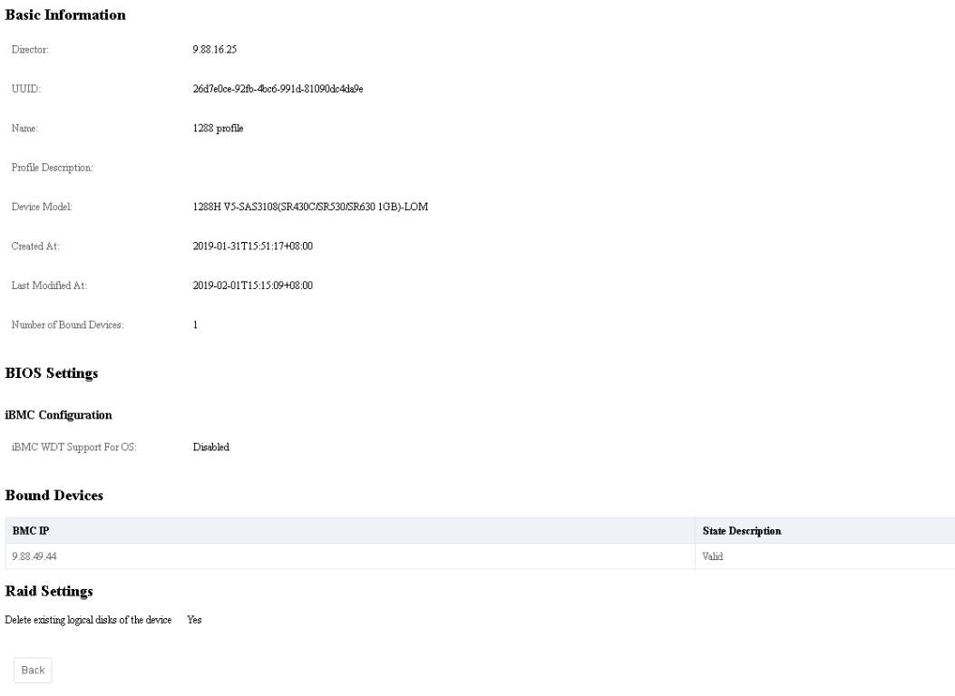

----End

Modifying a Server Profile
After a server profile is added, you can modify the server profile.
            - Log in to the SCCM server.
            - Choose Start > Configuration Manager Console to log in to the SCCM.
If Configuration Manager Console cannot be found on the Start panel, return to the desktop, right-click Start, choose Search from the shortcut menu, and enter Configuration Manager Console in the search box to find Configuration Manager Console.
The SCCM main window is displayed, as shown in Figure 1-1.
              - SCCM main window

            - Choose Huawei > Profile.
The server profile page is displayed, as shown in Figure 1-1. You can view the list of server profiles that have been created in the system.
              - Viewing server profiles

            - Click Modify in the Operation column of a specified server profile.
The page for modifying the server profile is displayed, as shown in Figure 1-1.
              - Modifying the server profile
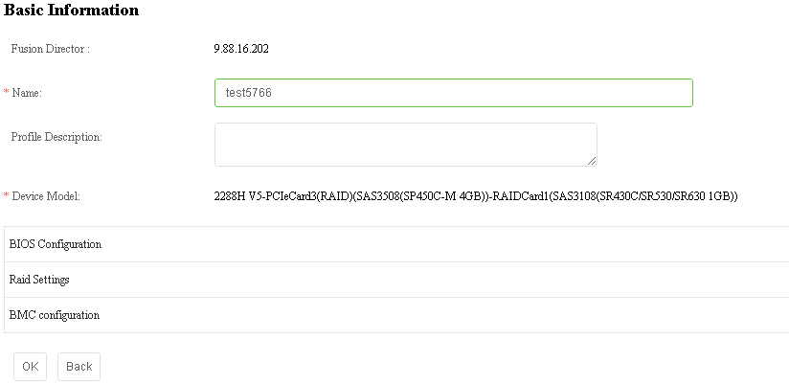

            - Click OK.
The server profile is modified successfully.
----End

Configuring Servers Using a Server Profile
After a server profile is added, you can use the server profile to configure the managed servers.
            - Log in to the SCCM server.
            - Choose Start > Configuration Manager Console to log in to the SCCM.
If Configuration Manager Console cannot be found on the Start panel, return to the desktop, right-click Start, choose Search from the shortcut menu, and enter Configuration Manager Console in the search box to find Configuration Manager Console.
The SCCM main window is displayed, as shown in Figure 1-1.
              - SCCM main window

            - Choose Huawei > Profile.
The server profile page is displayed, as shown in Figure 1-1. You can view the list of server profiles that have been created in the system.
              - Querying server profiles

            - Click Bind in the Operation column of a specified server profile.
On the displayed page, select a device to which the server profile is to be bound, as shown in Figure 1-1.
              - Binding the server profile to a device
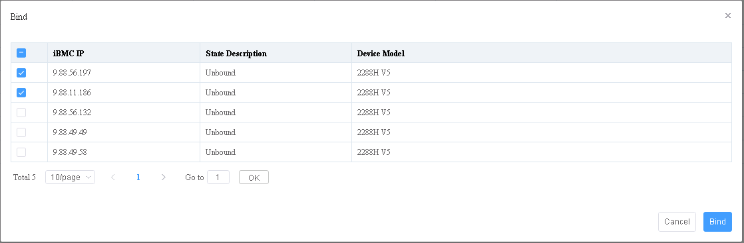

            - Click Bind.
The device is bound.
            - View the information about the bound device.
Go to the configuration query page and check the number of devices bound to the server profile, as shown in Figure 1-1.
              - Number of Bound Devices
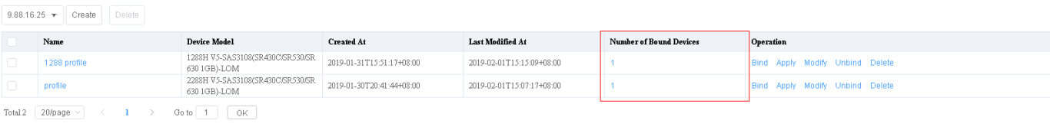

Click the number in the Number of Bound Devices column to view the information about the bound device, as shown in Figure 1-2.
              - Information about the bound device
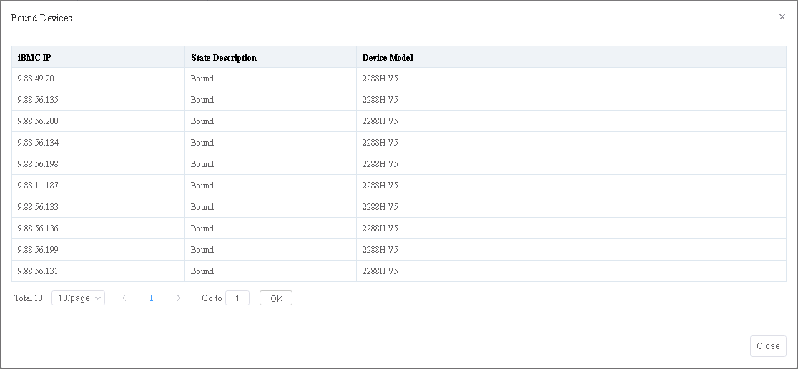

            - Click Apply in the Operation column of the server profile.
The page for applying the server profile is displayed, as shown in Figure 1-1. View the selected device to which the configuration is to be delivered.
              - Information about the bound device
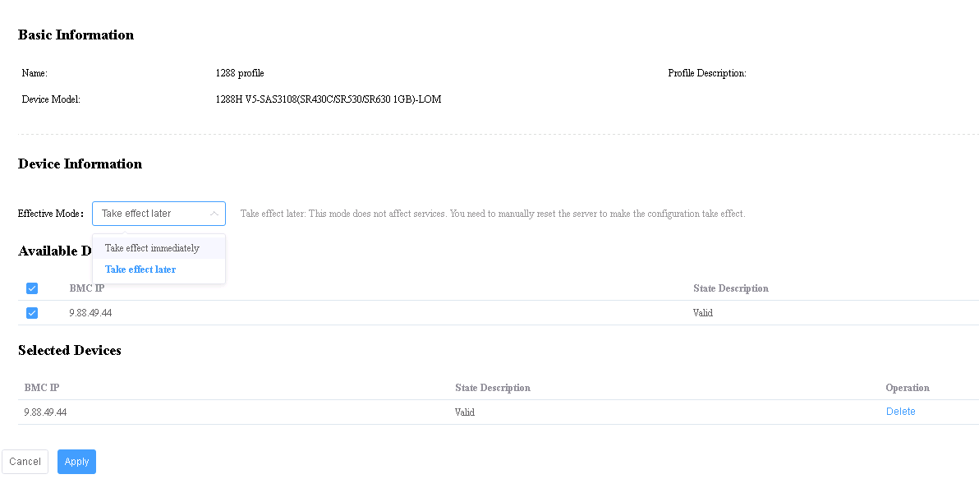

            - Click Apply.
After the configuration delivery is started, you can view the configuration delivery status in the task list.
----End

Deleting a Server Profile
Delete a server profile that is no longer used. Before deleting a profile, ensure that the profile is not bound to any device.
            - Log in to the SCCM server.
            - Choose Start > Configuration Manager Console to log in to the SCCM.
If Configuration Manager Console cannot be found on the Start panel, return to the desktop, right-click Start, choose Search from the shortcut menu, and enter Configuration Manager Console in the search box to find Configuration Manager Console.
The SCCM main window is displayed, as shown in Figure 1-1.
              - SCCM main window

            - Choose Huawei > Profile.
The server profile page is displayed, as shown in Figure 1-1. You can view the list of server profiles that have been created in the system.
              - Querying server profiles

            - Click Unbind.
The page for unbinding a server profile is displayed, as shown in Figure 1-1.
Select the device to be unbound. Click Unbind to unbind the device.
              - Unbinding the device
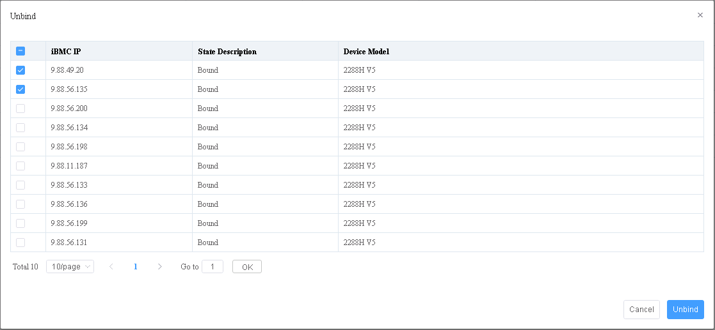

            - On the server profile page, click Delete in the Operation column of the server profile to be deleted.
The page for confirming the deletion of the server profile is displayed, as shown in Figure 1-1.
Click OK. The server profile is deleted successfully.
              - Confirming the deletion
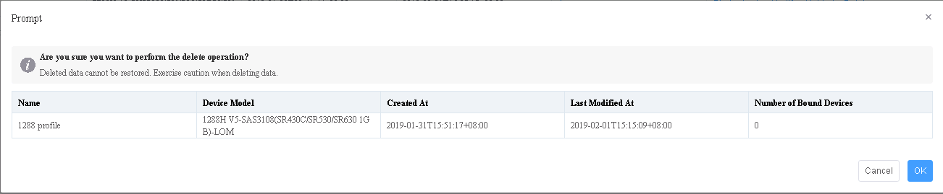

----End

Upgrading Firmware and Drivers
- Upgrade for the out-of-band firmware BMC, BIOS, and CPLD is supported.
- Upgrade for the in-band firmware RAD controller card and NIC is supported.
- Upgrade for the Smart Provisioning firmware, power supply firmware, and drivers is supported.

Version Repository Management

Uploading an Update Package
Prerequisites
- To upgrade the in-band firmware, the Smart Provisioning version must be 1.18 or later.
- You have obtained Huawei baseline and firmware packages from Huawei Online Upgrade Platform (HOUP).
- You have obtained the software packages and digital signatures from Huawei Support website.
Automatically Obtaining an Update Package
            - Log in to the SCCM server.
            - Choose Start > Configuration Manager Console to log in to the SCCM.
If Configuration Manager Console cannot be found on the Start panel, return to the desktop, right-click Start, choose Search from the shortcut menu, and enter Configuration Manager Console in the search box to find Configuration Manager Console.
The SCCM main window is displayed, as shown in Figure 1-1.
              - SCCM main window

            - Choose Huawei > HuaweiFirmware Update > Version Repository.
The Baseline page is displayed, as shown in Figure 1-1.
              - Baseline
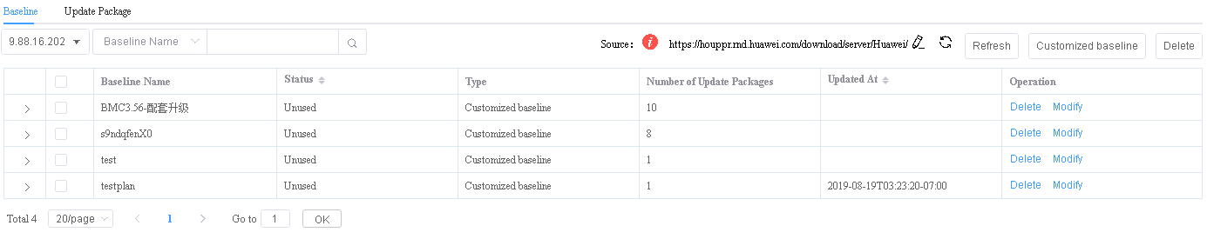

            - Select a FusionDirector system.
            - Click and enter the source of the software package, as shown in Figure 1-1.
              - Source
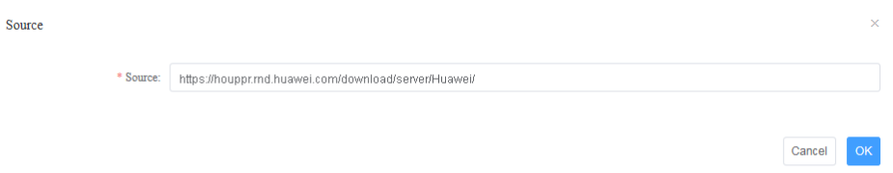

            - Click OK.
- : indicates that the connection to the online address fails. Rectify the fault according to the handling suggestions.
  - Check whether the website is correct.
  - Check whether the DNS or proxy is available.
If the problem persists, contact Huawei technical support.
- : indicates that the online address can be accessed. FusionDirector automatically synchronizes the update package and baseline from the online address in the background. SCCM automatically obtains the update package and baseline synchronized from FusionDirector.
Click > next to a baseline name to view the automatically obtained update package and baseline.
            - Click the Update Package tab. On the page, view the automatically obtained update package.
----End
Manually Uploading an Update Package
            - Log in to the SCCM server.
            - Choose Start > Configuration Manager Console to log in to the SCCM.
If Configuration Manager Console cannot be found on the Start panel, return to the desktop, right-click Start, choose Search from the shortcut menu, and enter Configuration Manager Console in the search box to find Configuration Manager Console.
The SCCM main window is displayed, as shown in Figure 1-1.
              - SCCM main window

            - Choose Huawei > Firmware Update > Version Repository. Click the Update Package tab.
The Update Package page is displayed, as shown in Figure 1-1.
              - Update package
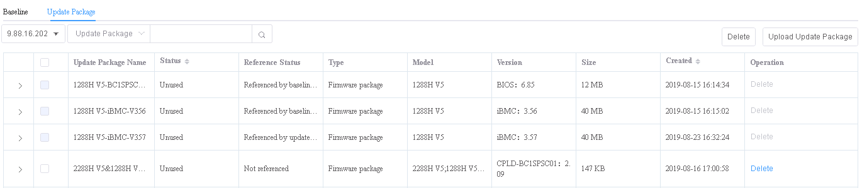

            - Click Upload Update Package.
The Upload Update Package page is displayed. Set the following parameters, as shown in Figure 1-1.
              - Uploading an update package
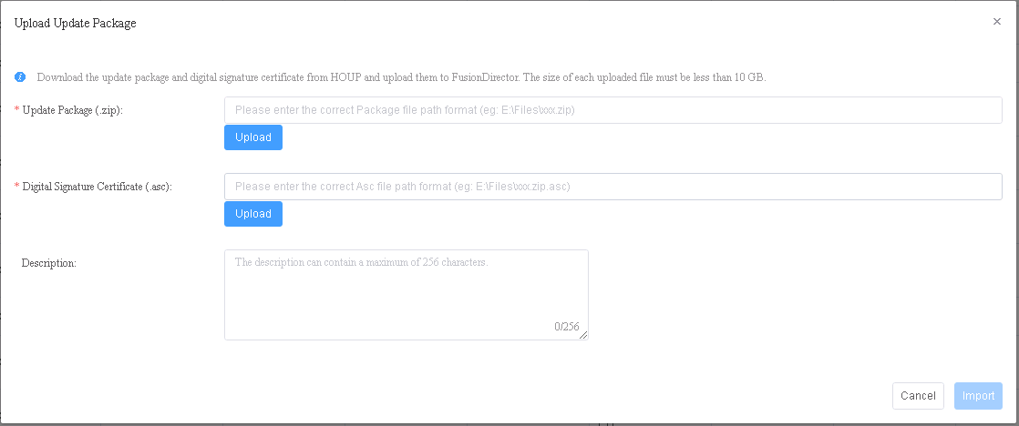

- Update Package (.zip): Enter the path of the local update package and upload the update package in .zip format.
- Digital Signature Certificate (.asc): Enter the path of the local digital signature file and upload the digital signature certificate file in .asc format.
- Description: indicates the update package description.
            - Click Import.
The update package is imported.
You can view the uploaded update packages on the Update Package page, as shown in Figure 1-1.
              - Update package

To delete an uploaded update package, click Delete in the Operation column. The package which is referenced by the baseline or is being used cannot be deleted.
----End

Customizing a Baseline
Automatically Obtaining a Baseline
            - Log in to the SCCM server.
            - Choose Start > Configuration Manager Console to log in to the SCCM.
If Configuration Manager Console cannot be found on the Start panel, return to the desktop, right-click Start, choose Search from the shortcut menu, and enter Configuration Manager Console in the search box to find Configuration Manager Console.
The SCCM main window is displayed, as shown in Figure 1-1.
              - SCCM main window

            - Choose Huawei > Firmware Update > Version Repository.
The Baseline page is displayed, as shown in Figure 1-1.
              - Baseline

            - Select a FusionDirector system.
            - Click and enter the source of the baseline, as shown in Figure 1-1.
              - Source

            - Click OK.
- : indicates that the connection to the online address fails. Rectify the fault according to the handling suggestions.
  - Check whether the website is correct.
  - Check whether the DNS or proxy is available.
If the problem persists, contact Huawei technical support.
- : indicates that the online address can be accessed. FusionDirector automatically synchronizes the update package and baseline from the online address in the background. SCCM automatically obtains the update package and baseline synchronized from FusionDirector.
Click > next to a baseline name to view the automatically obtained update package and baseline.
----End
Manually Customizing a Baseline
            - Log in to the SCCM server.
            - Choose Start > Configuration Manager Console to log in to the SCCM.
If Configuration Manager Console cannot be found on the Start panel, return to the desktop, right-click Start, choose Search from the shortcut menu, and enter Configuration Manager Console in the search box to find Configuration Manager Console.
The SCCM main window is displayed, as shown in Figure 1-1.
              - SCCM main window

            - Choose Huawei > Firmware Update > Version Repository.
The Baseline page is displayed, as shown in Figure 1-1.
              - Baseline

            - Click Customized baseline.
The Customized baseline page is displayed. Set the following parameters, as shown in Figure 1-1.
              - Customizing a baseline
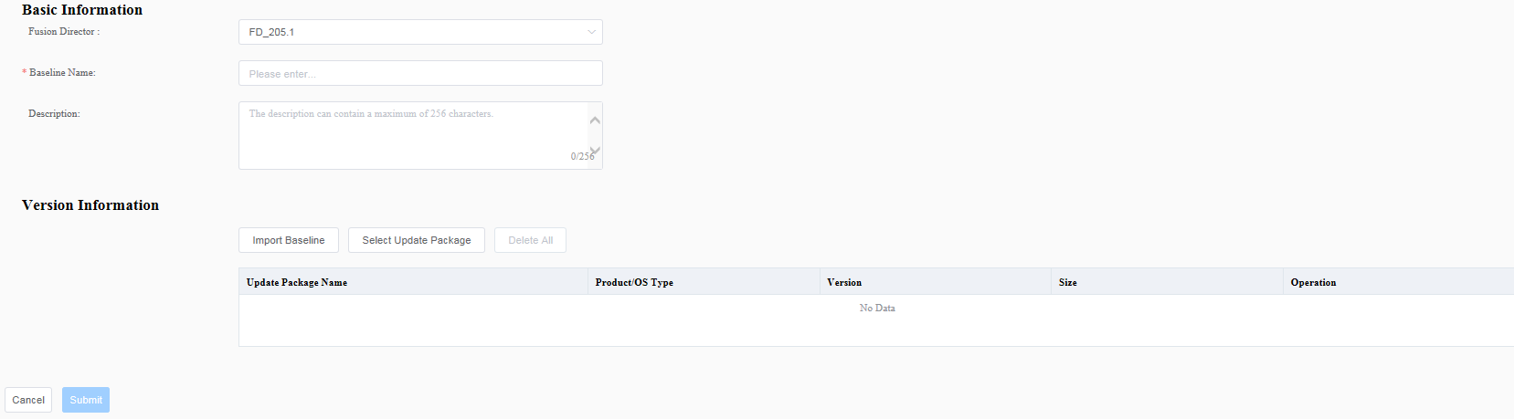

- Fusion Director: selects a FusionDirector system.
- Baseline Name: indicates the baseline name.
- Description: indicates the baseline description.
- Version Information: imports an existing baseline or update package.
- Import Baseline: selects the created baselines to form an update package for the customized baseline.
- Select Update Package: selects the uploaded update packages to form an update package for the customized baseline.
            - Click Submit.
The baseline is created.
You can view the created baselines on the Baseline page, as shown in Figure 1-1.
              - Baseline

----End

Update Schedule Management

Creating an Update Schedule
            - Log in to the SCCM server.
            - Choose Start > Configuration Manager Console to log in to the SCCM.
If Configuration Manager Console cannot be found on the Start panel, return to the desktop, right-click Start, choose Search from the shortcut menu, and enter Configuration Manager Console in the search box to find Configuration Manager Console.
The SCCM main window is displayed, as shown in Figure 1-1.
              - SCCM main window

            - Choose Huawei > Firmware Update > Update Schedule.
The Update Schedule page is displayed, as shown in Figure 1-1.
              - Update schedule
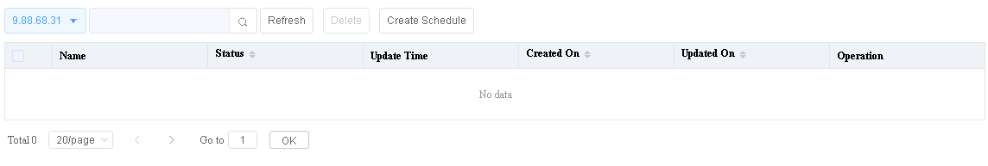

            - Click Create Schedule.
On the Select Device page, set the parameters and select groups or devices, as shown in Figure 1-1.
              - Selecting devices
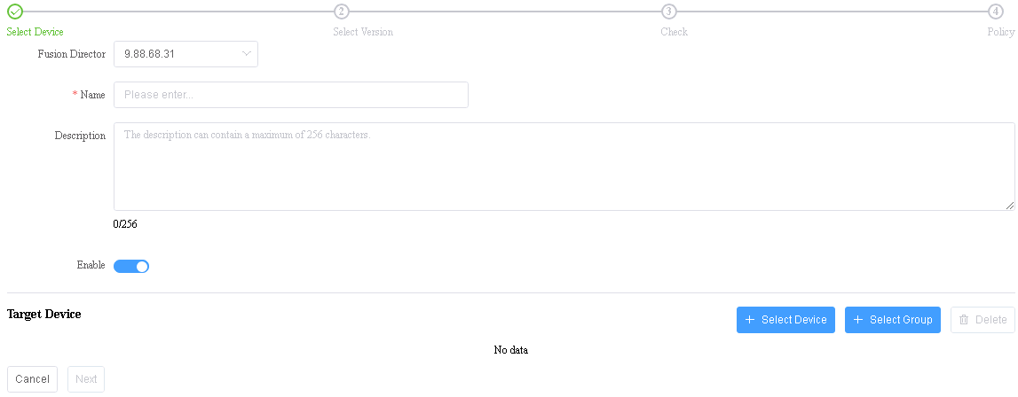

- Fusion Director: selects a FusionDirector system.
- Name: indicates the schedule name.
The value can contain 1 to 32 characters, including Chinese characters, letters, digits, hyphens (-), underscores (_), and dots (.).
- Description: indicates the schedule description.
- Enable: indicates whether to enable the update schedule. indicates that the schedule is enabled. indicates that the schedule is disabled.
- Select Device: You can click  to select the device to be updated.
- You can select only one of Select Device and Select Group.
- To delete a device, click Delete on the right.
- Select Group: You can click  to select the group to be updated.

Private groups created on FusionDirector are invisible on the SCCM. To make all groups visible, ensure that all groups are set to non-private groups when they are created.
- You can select only one of Select Device and Select Group.
- To delete a group, click Delete on the right.
            - Click Next.
The page for selecting baselines or update packages is displayed, as shown in Figure 1-1.
              - Selecting baselines or update packages
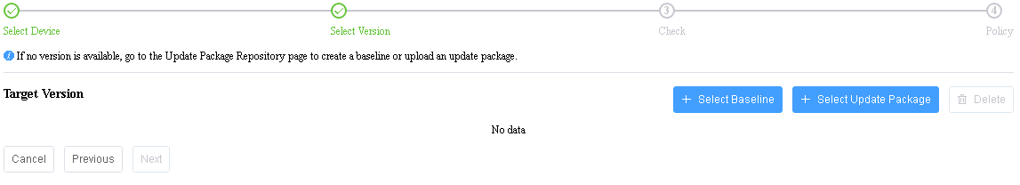

Click Select Baseline or Select Update Package to select the required update file.
- You can select only one of Select Baseline and Select Update Package.
- To delete a baseline or update package, click Delete on the right.
            - Click Next.
On the Update Report page, select the device to be updated, as shown in Figure 1-1.
- Click > on the left of the update report to view details about each update component.
- By default, firmware of the same version is not selected for update.
- By default, the in-band firmware and Smart Provisioning firmware is not selected for update.
              - Update report
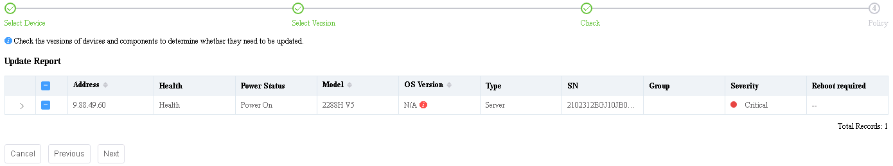

            - Click Next.
The Policy page is displayed, as shown in Figure 1-1.
              - Update policy
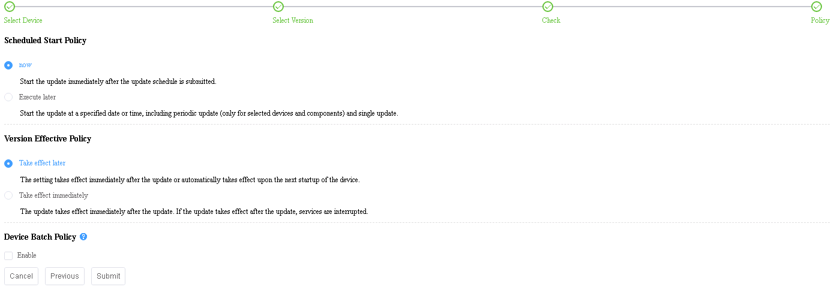

- Schedule Start Policy: selects the required scheduled start policy.
- Update now: After the schedule is submitted, the system updates the devices immediately.
- Execute later: After the schedule is submitted, the system executes the schedule at the specified date/time once or periodically for the selected devices and components. You can specify the week, date, or time for the update.
- Version Effective Policy: selects the required version effective policy.
- Take effect later: The update takes effect manually or takes effect upon the next startup of the device.
The BMC firmware update takes effect immediately even if you select Take effect later.
- Take effect immediately: The update takes effect immediately. If activation requires device restart, services will be interrupted
- Device Batch Policy: indicates whether to enable the device batch policy.
            - Click Submit.
The update schedule is created.
----End

Viewing the Update Schedule
            - Log in to the SCCM server.
            - Choose Start > Configuration Manager Console to log in to the SCCM.
If Configuration Manager Console cannot be found on the Start panel, return to the desktop, right-click Start, choose Search from the shortcut menu, and enter Configuration Manager Console in the search box to find Configuration Manager Console.
The SCCM main window is displayed, as shown in Figure 1-1.
              - SCCM main window

            - Choose Huawei > Firmware Update > Update Schedule.
The Update Schedule page is displayed, as shown in Figure 1-1.
              - Update schedule
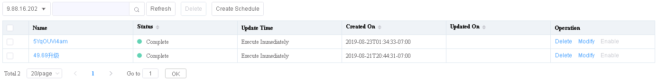

            - Click the name of the update schedule to view the details, as shown in Figure 1-1.
              - Detailed update schedule
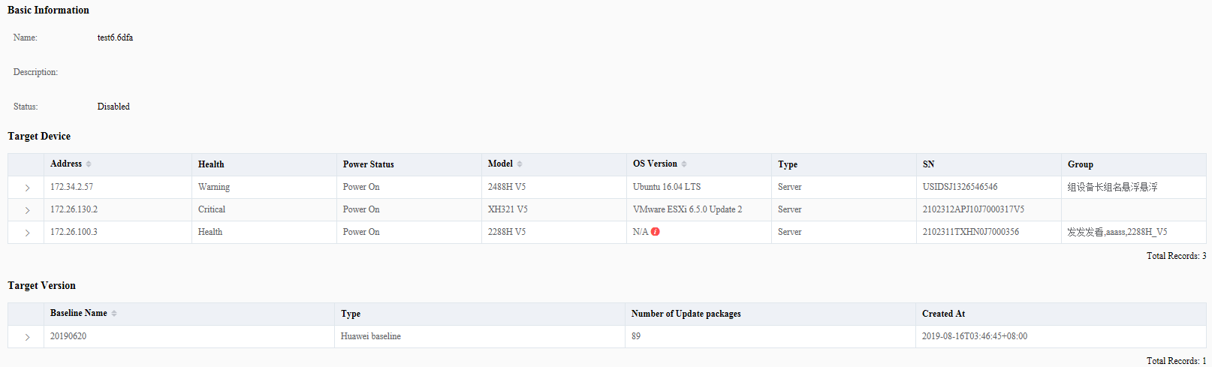

----End

Checking Device Version and Status
            - Log in to the SCCM server.
            - Choose Start > Configuration Manager Console to log in to the SCCM.
If Configuration Manager Console cannot be found on the Start panel, return to the desktop, right-click Start, choose Search from the shortcut menu, and enter Configuration Manager Console in the search box to find Configuration Manager Console.
The SCCM main window is displayed, as shown in Figure 1-1.
              - SCCM main window

            - Choose Huawei > Firmware Update > Device Version Information.
The Device Version Information page is displayed, as shown in Figure 1-1.
              - Device version information
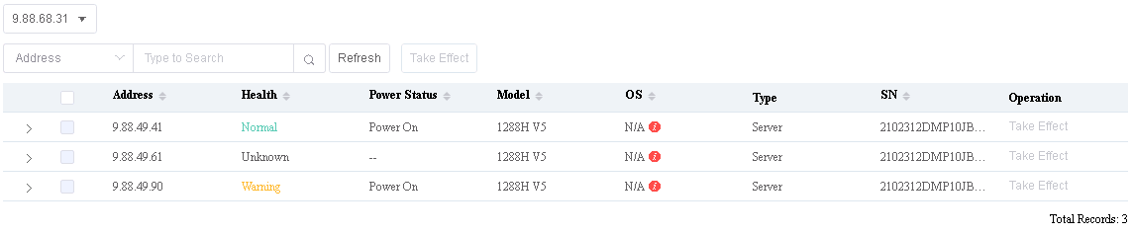

            - Select a FusionDirector system.
            - In the server list, click to view the device version information of the server, as shown in Figure 1-1.
              - Detailed device version information
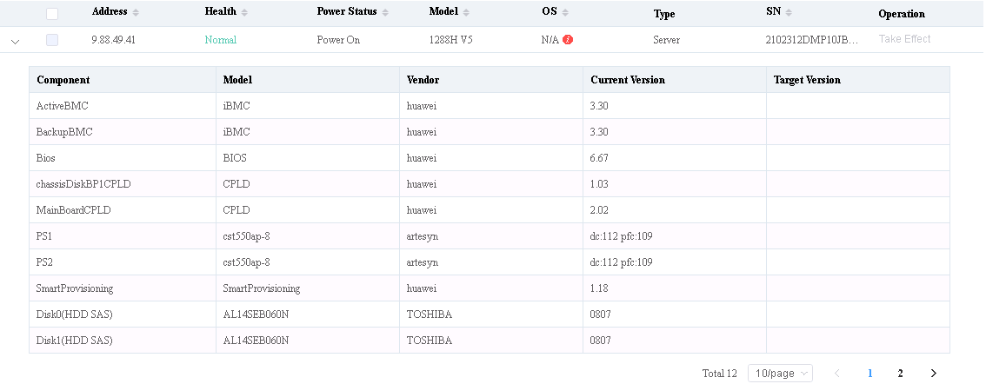

----End

Managing Tasks
Manage FusionDirector tasks on the SCCM.
Procedure
            - Log in to the SCCM server.
            - Choose Start > Configuration Manager Console to log in to the SCCM.
If Configuration Manager Console cannot be found on the Start panel, return to the desktop, right-click Start, choose Search from the shortcut menu, and enter Configuration Manager Console in the search box to find Configuration Manager Console.
The SCCM main window is displayed, as shown in Figure 1-1.
              - SCCM main window

            - Choose Huawei > Task.
The Task page is displayed. On the Task page, you can query and delete tasks, as shown in Figure 1-1.
              - Task page
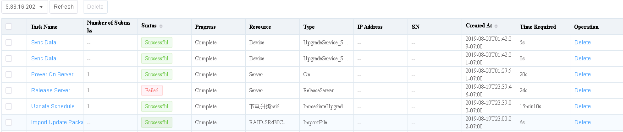

----End

Viewing the Huawei SCCM Plug-in Version
Procedure
            - Log in to the SCCM server.
            - Choose Start > Configuration Manager Console to log in to the SCCM.
If Configuration Manager Console cannot be found on the Start panel, return to the desktop, right-click Start, choose Search from the shortcut menu, and enter Configuration Manager Console in the search box to find Configuration Manager Console.
The SCCM main window is displayed, as shown in Figure 1-1.
              - SCCM main window

            - Choose Huawei > About.
The About window is displayed, as shown in Figure 1-1.
              - About


The value of Version is the Huawei SCCM plug-in version.
----End

FAQs
4.1 Connection Test Failed When You Add FusionDirector Server
4.2 DLL File Is Missing When the SCCM Plug-in Is Used

Connection Test Failed When You Add FusionDirector Server
Symptom
After a FusionDirector server is added, a failure message is displayed during the connection test.
Cause
- The network is abnormal.
- The user name or password is incorrect.
- The FusionDirector northbound interface user is locked.
Solution
- The network is abnormal.
Ensure that the network between the SCCM and FusionDirector is normal.
- The user name or password is incorrect.
You need to connect to FusionDirector as the rootRedfish user. Contact FusionDirector O&M personnel to obtain the correct rootRedfish user password.
- The FusionDirector northbound interface user is locked.
After being locked, the FusionDirector northbound interface user can be unlocked 5 minutes later.

DLL File Is Missing When the SCCM Plug-in Is Used
Symptom
When the SCCM plug-in is used, a message is displayed indicating that the DLL file is missing, as shown in the following figure.
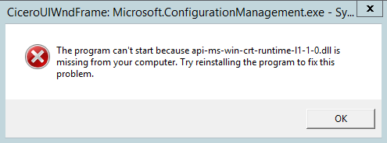
Solution
            - Install Visual C++ Redistributable for Visual Studio downloaded from
https://www.microsoft.com/en-us/download/confirmation.aspx?id=48145
- If the installation is successful, go to Step 2.
- If the installation fails, go to Step 3.
            - Access the SCCM plug-in and check whether the problem is resolved.
- If yes, no further action is required.
- If no, go to Step 3.
            - Download and install following patches for the Windows OS.
- Install patch KB2919442 downloaded from
https://www.microsoft.com/en-us/download/details.aspx?id=42153
- Install all patches of Windows Server 2012 R2 Update (KB2919355) downloaded from
https://www.microsoft.com/en-us/download/details.aspx?id=42334
Patches must be installed in the following sequence:
Sequence | Patch | Size | Remarks
1 | clearcompressionflag.exe | 38 KB | Run the patch as administrator. The installation is performed in the background without interfaces.
2 | Windows8.1-KB2919355-x64.msu | 690.8 MB | Restart the system after the installation. The process takes some time.
3 | Windows8.1-KB2932046-x64.msu | 48.0 MB | -
4 | Windows8.1-KB2934018-x64.msu | 126.4 MB | -
5 | Windows8.1-KB2937592-x64.msu | 303 KB | -
6 | Windows8.1-KB2938439-x64.msu | 19.6 MB | -
7 | Windows8.1-KB2959977-x64.msu | 2.8 MB | -

After a patch is installed, restart the system as prompted for the patch to take effect. You can restart the system after all patches are installed.
- Reinstall Visual C++ Redistributable for Visual Studio.
----End
- Obtaining Help
  - Preparing to Contact Huawei Technical Support
If a fault persists during routine maintenance or troubleshooting, contact Huawei technical support.
To rectify a fault, make the following preparations before you contact Huawei technical support.
Collecting Fault Information
You need to collect the following information:
- Your company name and detailed address
- Name and telephone number of the contact person
- Time when the fault occurred
- Fault symptom
- Device type and software version
- Measures taken after the fault occurred and results
- Fault severity and deadline for rectifying the fault
Preparing for Debugging
When you seek technical support, Huawei technical support may ask you to perform some operations to further collect fault information or even rectify the fault. You need to make preparations before seeking technical support. For example, prepare spare server parts and controller cards, screwdrivers, screws, serial cables, network cables, and other necessary objects.
  - Obtaining Help from Huawei Support Website
Huawei provides timely and efficient technical support over local offices, secondary technical support systems, telephones, remote technologies, and onsite instructions.
Huawei technical support system consists of:
- Technical Support Department at Huawei Headquarters
- Technical support centers in local offices
- Huawei support website
- Customer service center
Huawei support website: http://support.huawei.com/enterprise
To view the latest product documentation at http://support.huawei.com, perform the following steps:
- Log in to http://support.huawei.com/enterprise.
- Click Login. The Login page is displayed.
- Enter your user name, password, and verification code, and click Login. The Technical Support page is displayed.
- In the navigation tree, click TECHNICAL SUPPORT > Technical Support > Product and Solution Support and select a product manual based on the product name.
Alternatively, you can quickly locate a product manual by entering a keyword in the Search text box in the upper right corner of the web page.

